This invention relates to mechanical instrument for measure the mass and acceleration of objects under the theory of universal relativity, which will update the General and special theory of relativity while the time is universe.

**Prior Art**

1. **Simple Pendulum:**

A simple pendulum consists of light in extensible flexible string of length “l” suspended from a point “S”. A heavy bob is tied to the string. In equilibrium position the weight Mg is equal to the tension T. (Fig 1)

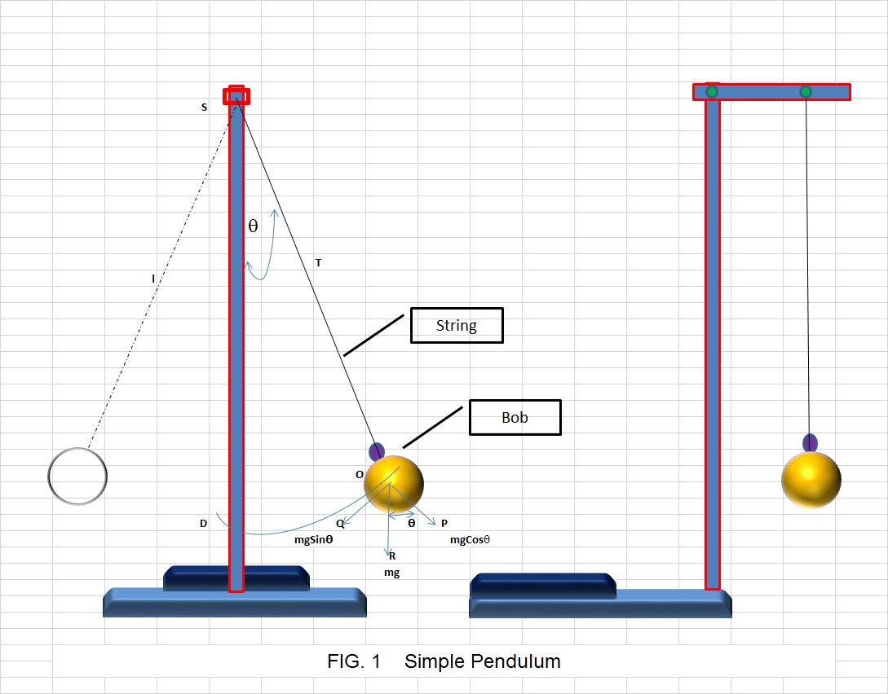

A simple harmonic vibration is defined as that one in which the acceleration is proportional to the displacement and is always directed towards the mean position of rest. Let the bob of pendulum be displaced by a small angle θ and released. The bob executes simple harmonic oscillations.

Let O be the displaced position at any instant.

The weight mg acts in the direction OR. Resolve this force into two components mg Cos(θ) along OP parallel to the string and mg Sin(θ) along OQ perpendicular to the string. The component mg Cos(θ) balances the tension T and the component mg Sin(θ) is the force required for the bob to return to its original position.

Therefore, Force acting on the bob = mg Sin(θ)

F = mg Sin(θ)

ma = mg Sin(θ)

a = g Sin(θ)

for small amplitude, θ is small

Sin(θ) = OD / OS

a = g (OD/OS)

here

OD = displacement

OS = l

In case of simple harmonic oscillations the time period of oscillation “t” is given by the equation.

t = $2\sqrt{displacemnet/acceleration}$ = $2\sqrt{ l/g}$

1. **Special relativity**

Special relativity is a theory of the structure of space time. It was introduced in Einstein's 1905 paper "On the Electrodynamics of Moving Bodies". Special relativity is based on two postulates which are contradictory in classical mechanics:

1. The laws of physics are the same for all observers in uniform motion relative to one another (principle of relativity).
2. The speed of light in a vacuum is the same for all observers, regardless of their relative motion or of the motion of the source of the light.

The resultant theory copes with experiment better than classical mechanics, Some of these are:

* Relativity of simultaneity: Two events, simultaneous for one observer, may not be simultaneous for another observer if the observers are in relative motion.
* Time dilation: Moving clocks are measured to tick more slowly than an observer's "stationary" clock.
* Length contraction: Objects are measured to be shortened in the direction that they are moving with respect to the observer.
* Mass–energy equivalence: *E* = *mc*2, energy and mass are equivalent and transmutable.
* Maximum speed is finite: No physical object, message or field line can travel faster than the speed of light in a vacuum.

## General relativity

General relativity is a theory of gravitation developed by Einstein in the years 1907–1915. The development of general relativity began with the [equivalence principle](http://en.wikipedia.org/wiki/Equivalence_principle), under which the states of [accelerated motion](http://en.wikipedia.org/wiki/Accelerated_motion) and being at rest in a [gravitational field](http://en.wikipedia.org/wiki/Gravity) are physically identical. The upshot of this is that [free fall](http://en.wikipedia.org/wiki/Free_fall) is [inertial motion](http://en.wikipedia.org/wiki/Inertia); an object in free fall is falling because that is how objects move when there is no [force](http://en.wikipedia.org/wiki/Force) being exerted on them, instead of this being due to the force of [gravity](http://en.wikipedia.org/wiki/Gravity) as is the case in [classical mechanics](http://en.wikipedia.org/wiki/Classical_mechanics). This is incompatible with classical mechanics and [special relativity](http://en.wikipedia.org/wiki/Special_relativity) because in those theories inertially moving objects cannot accelerate with respect to each other, but objects in free fall do so. To resolve this difficulty Einstein first proposed that space time is [curved](http://en.wikipedia.org/wiki/Curvature). In 1915, he devised the [Einstein field equations](http://en.wikipedia.org/wiki/Einstein_field_equations) which relate the curvature of space time with the mass, energy, and momentum within it. Some of the consequences of general relativity are:

* Clocks run more slowly in deeper gravitational wells. This is called gravitational time dilation.
* Orbits precess in a way unexpected in Newton's theory of gravity. (This has been observed in the orbit of Mercury and in binary pulsars).
* Rays of [light](http://en.wikipedia.org/wiki/Light) bend in the presence of a gravitational field.
* Rotating masses "drag along" the space time around them; a phenomenon termed "frame-dragging".
* The Universe is expanding, and the far parts of it are moving away from us faster than the speed of light.

Technically, general relativity is a theory of gravitation whose defining feature is its use of the Einstein field equations. The solutions of the field equations are metric tensors which define the topology of the space time and how objects move inertially.

**This invention relates to mechanical instrument** is comprises wooden bob attached at the end of inextensible flexible string and other end attached at rigid fixed centre point of weigh load cell cum weigh indicator at vertical metallic protractor and the vertical metallic protractor is mounted with the top of vertical post and the bottom of post is fixed at the liquid tank. The said liquid tank is comprises the liquid overflow collecting arrangement to collect the liquid during the presence of overflow on liquid.

**DESCRIPTION OF THE DRAWINGS**

The invention will be more fully understood from the following detailed description taken in conjunction with the accompanying drawings in which:

FIG. 2 is a Front view and side of a mechanical instrument according to the present invention;

No 1 of FIG. 2 is signifying protractor to measure the angle “θ” of swing

No 2 of FIG. 2 is signifying weigh load cell cum weigh indicator to measure the mass “m” and force “ma”

No 3 of FIG. 2 is signifying no friction pivot as rigid fixed centre point

No 4 of FIG. 2 is signifying inextensible flexible string

No 5 of FIG. 2 is signifying vertical post

No 6 of FIG. 2 is signifying wooden bob with known radius “r’ and density “kg/ $m^{3}"$

No 7 of FIG. 2 is signifying liquid with known density “kg/ $m^{3}"$

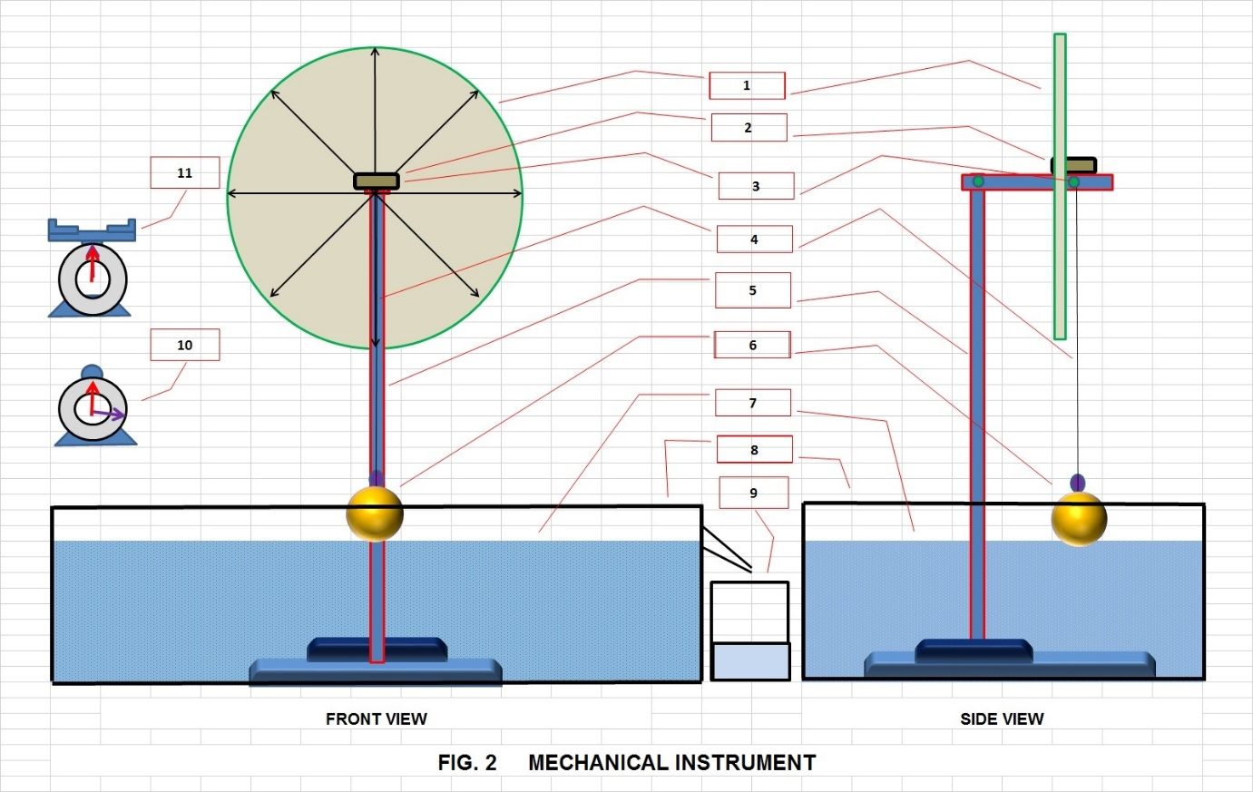

No 8 of FIG. 2 is signifying liquid tank with overflow collecting arrangement

No 9 of FIG. 2 is signifying collecting jar

No 10 of FIG. 2 is signifying Stop watch

No 11 of FIG. 2 is signifying weigh scale

**DETAILED DESCRIPTION OF THE INVENTION**

FIG.2 The present invention relates to a **mechanical instrument** is comprises wooden bob attached at the end of inextensible flexible string and other end attached at rigid fixed centre point of weigh load cell cum weigh indicator at vertical metallic protractor and the vertical metallic protractor is mounted with the top of vertical post and the bottom of post is fixed at the liquid tank. The said liquid tank is comprises the liquid overflow collecting arrangement to collect the liquid during the presence of overflow on liquid.

No 6 of FIG 2 is signifying wooden bob is attached with No 4 of FIG 2 is signifying inextensible string and the wooden bob is made to swing over the No 1 of FIG. 2 is signifying protractor to measure the angle “θ”of swing during the time “t’ on No 10 of FIG. 2 is signifying Stop watch and The mass “m” and force “ma” of wooden bob is measured during the swing on No 2 of FIG. 2 is signifying weigh load cell cum weigh indicator.

Once the data for angle “θ”, mass “m”, force “mg”, the wooden bob is made free from string attachment and allowed to float on No 7 of FIG. 2 is signifying liquid of No 8 of FIG. 2 is signifying liquid tank with overflow collecting arrangement to collect the overflow of liquid at No 9 of FIG. 2 is signifying collecting jar and the mass of liquid is measured by No 11 of FIG. 2 is signifying weigh scale to get the mass of wooden bob.

**The data collected as per the present invention and it is substituting the variable to measure the mass and acceleration of objects under the theory of universal relativity.**

Force “F” is equal to product of mass “m” and acceleration “g” in other words the force is defines as is equal to the product of square of either angler or linear velocity “v” with mass “m” and inverse to the radius “r” of bob. In this lab apparatus that velocity “v” is nothing but the angular velocity hence it is equal to the product of angle “θ” with radius “R” and inverse to the time “T”.

F = mg = $\frac{mv^{2}}{r}$

g = $\frac{v^{2}}{r}$

here v = $\frac{R}{T}$

hence $\frac{v^{2}}{r}$ = $\frac{{R^{2}}^{2}}{rT^{2}}$

g = $\frac{{R^{2}}^{2}}{rT^{2}}$

Therefore, Gravitational force is nothing but the centrifugal force of three dimensions are as “r” is perpendicular line between centre of gravity point and till the limit of body and “v” is nothing but the displacement “m” upon time “t”. Also the Gravitational force is acting as a relative force within the limitation of said centrifugal force to fix the state of motions on each and every body to confirm the following equations while ensuring that the time “t” is universe and the mass “m” is vary.

**Universal relativity equation**

**Equation I**

The force is defines as is equal to the product of square of velocity with mass and inverse to the radius

F = ma = $\frac{mv^{2}}{r}$

**Equation II**

When the body stating at rest under the gravitational force is acting as relative force, the acceleration is equal to the square of velocity and inverse to the radius

g = $\frac{v^{2}}{r}$

**Equation III**

When the body is pushing to state at rest from its motion under the gravitational force is acting as relative force, the mass is equal to the product of rest force (mg) with radius “r” and inverse to square of relative velocity “v”

$\frac{r}{v^{2}}$ mg = m

**Equation IV**

When the body is in motion under the gravitational force is acting as relative force, the mass must be greater than the product of rest force (mg) with radius “r” and inverse to square of relative velocity “v”

$\frac{r}{v^{2}}$ m g < m

**Equation V**

When the body is floating on the air under the gravitational force is acting as relative force, one is greater than the product of rest force (mg) with radius “r” and inverse to square of relative velocity “v”

$\frac{r}{v^{2}}$ m g < 1

**Equation VI**

When the body floating on the liquid under the gravitational force is acting as relative force, the mass is less than the product of rest force (mg) with radius “r” and inverse to square of relative velocity “v”

$\frac{r}{v^{2}}$ m g > m

**Equation VII**

The energy “E” of each and every body is equal to the product of mass with square of velocity

F =

F * r = mv2

Therefore

E = mv2

**Equation VIII: Escape Velocity**

The escape velocity is defined as by the equation V

$\frac{r}{V^{2}}$ m g < 1

r m g < V2

V >

The body of mass “m” in escaping from the relative attraction force “g” at the above mentioned velocity.

**Conclusion**

Gravitational force is nothing but the centrifugal force of three dimensions are as “r” is perpendicular line between centre of gravity point and till the limit of body and “v” is nothing but the displacement “m” upon time “t”. Also the Gravitational force is acting as a relative force within the limitation of said centrifugal force to fix the state of motions on each and every body to confirm the following equations while ensuring that the time “t” is universe and the mass “m” is vary